S_ALR_87013099 -

Functionality
This transaction allows you to compare the costs of to separate cost collectors.
The reporting time frame can be cumulative or limited.
Two orders are compared with each other on the basis of cost elements.
Only the actual costs of two product cost collectors can be compared, because no planned costs are updated on product cost collectors.
In Product Cost Controlling costs are collected on Product Cost Collectors with order types:
RM01 - PCC for Repetitive Manufacturing
RM01 - PCC for Process Orders
CP01 – CO Production Order
Scenario
Two orders for different production versions of the same product will be used as an example.

Requirements
None.

Menu Path | Accounting → Controlling → Product Cost Controlling → Cost Object Controlling → Product Cost by Period → Information System → Reports for Product Cost by Period → Object Comparisons → S_ALR_87013099 - Order vs. Order Plan/Actual Comparison
Transaction Code | S_ALR_87013099

1. Double click on the S_ALR_87013099 - Order vs. Order Plan/Actual Comparison.

Plan/Actual Comparison: Selection

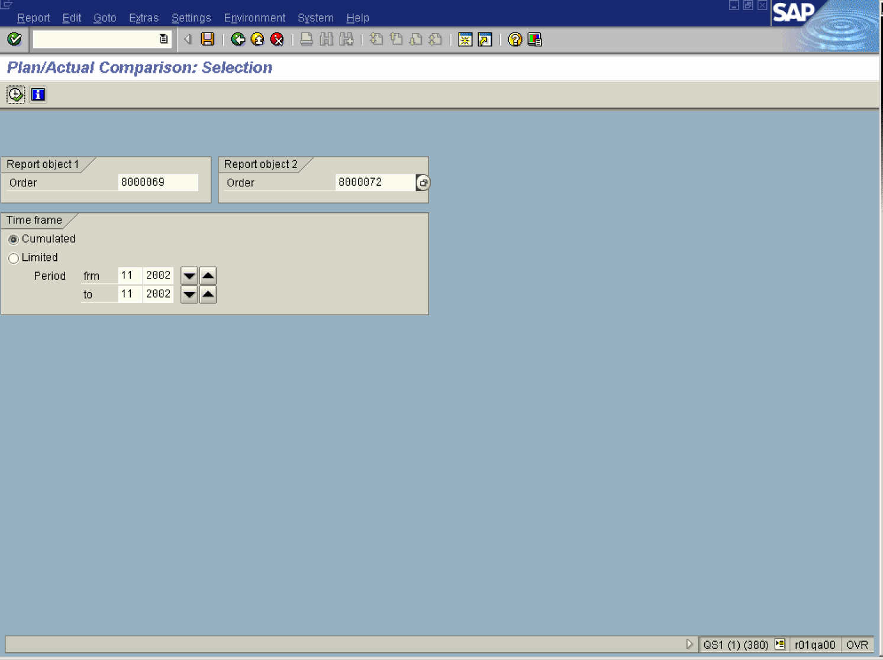

2. Update the following fields:

Field Name | Field Description | Values
Order | Number identifying the order | Example: 8000069
Order | Number identifying the order | Example: 8000072

3. Click the Execute button.

Plan/actual comparison

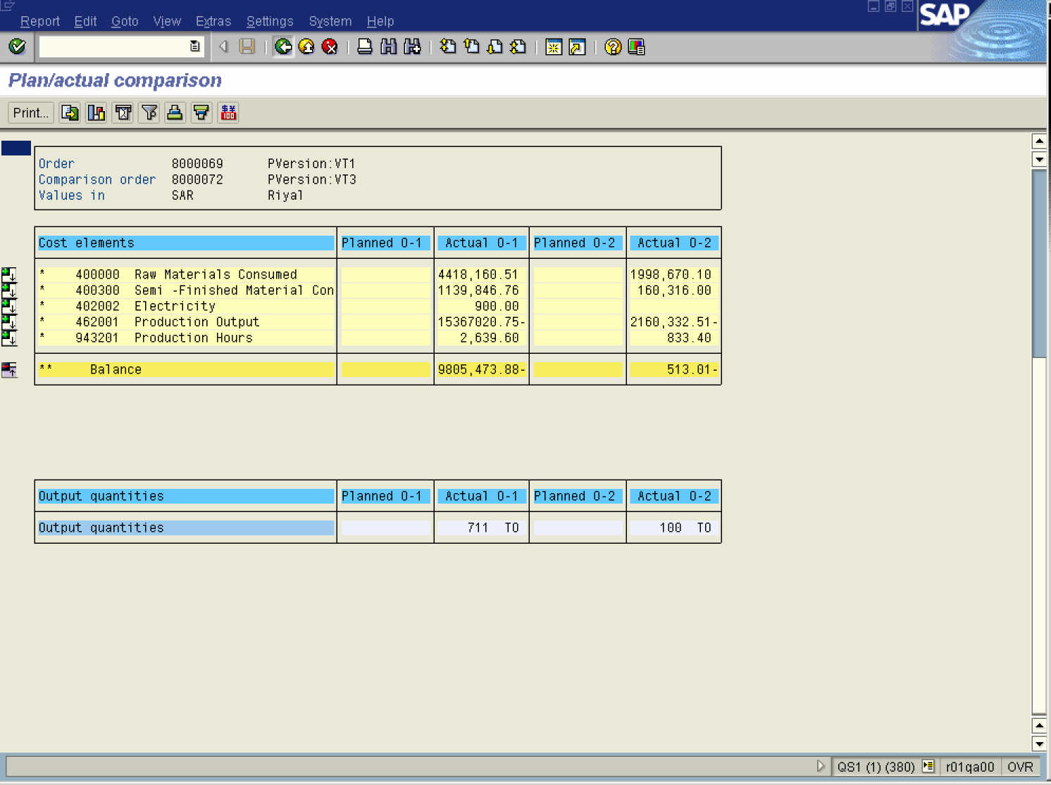

4. Click the Back button.

Exit Report

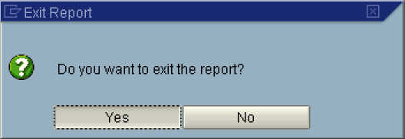

5. Click the Yes button.
Plan/actual comparison

6. Click the Back button to go back to SAP Easy Access screen.

